Step 1 – Added two Jobserver nodes with the Name’s as “Jobserver1” and “Jobserver2” and the system automatically took the Services name as “Jobserver”
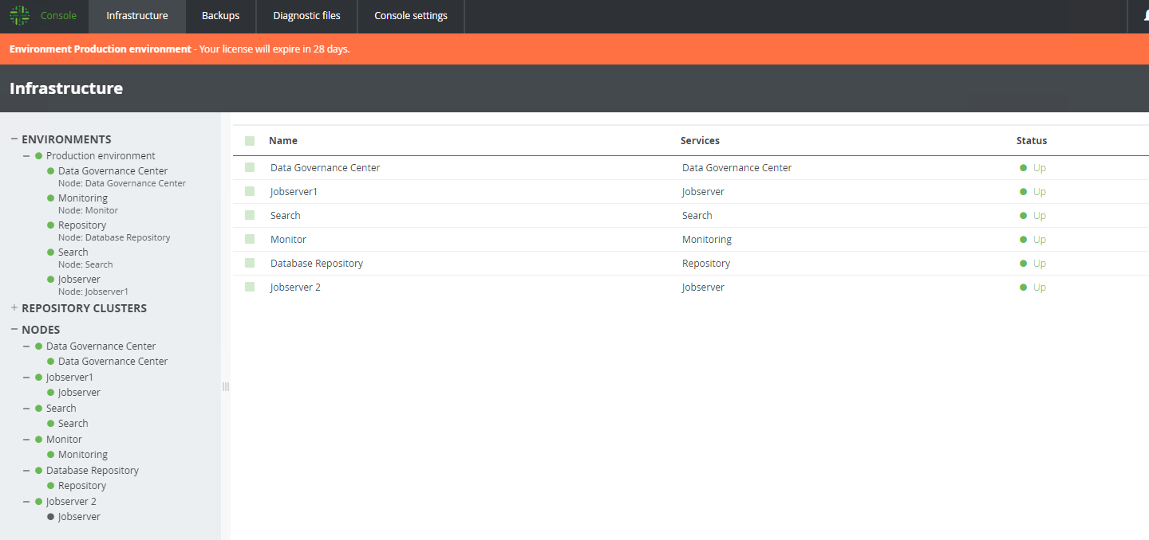
Step 2: I can only add only one Jobserver node to the environment
